M I N U T E S

T O W N O F S E X S M I T H

PUBLIC HEARING MEETING, TO ADOPT BYLAW NO. 1102 – LAND USE AMENDMENT

MONDAY JANUARY 19, 2026
*****************************************************************
Mayor Potter called this Public Hearing meeting of Town Council to order at 6:30 p.m. at the Sexsmith Town Council Chambers

COUNCIL PRESENT
  Kate Potter  Pauline Nelson  Dennis Stredulinsky  Daycie Bohning  Ken Hildebrand  Chrystal Widsten  Bruce Black | Mayor  Councillor  Councillor  Deputy Mayor  Councillor  Councillor  Councillor
COUNCIL ABSENT
STAFF PRESENT
  Rachel Wueschner  Alex Wories | CAO  Assistant CAO
ADOPTION OF AGENDA | RESOLUTION NO. 013-01-26  Moved by Councillor Bohning that the agenda for the Public Hearing meeting be accepted as presented.  CARRIED
PUBLIC HEARING
ADJOURNMENT | Meeting adjourned at 7:12 p.m.  CARRIED

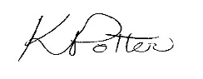
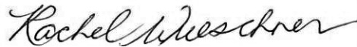

Kate Potter, Mayor Rachel Wueschner
Chief Administrative Office

