M I N U T E S

T O W N O F S E X S M I T H

BUDGET MEETING

MONDAY MARCH 30, 2026
*****************************************************************
Mayor Potter called the Budget Meeting of Town Council to order at 6:31 p.m.

COUNCIL PRESENT | Kate Potter  Dennis Stredulinsky  Daycie Bohning  Ken Hildebrand  Pauline Nelson  Chrystal Widsten | Mayor  Councillor  Deputy Mayor  Councillor  Councillor  Councillor
COUNCIL ABSENT | Bruce Black (Leave of Absence) | Councillor
STAFF PRESENT | Rachel Wueschner  Alex Wories | Chief Administrative Officer  Assistant CAO
ADOPTION OF AGENDA | RESOLUTION NO. 128-03-26  Moved by Councillor Stredulinsky that the agenda for this meeting be adopted as presented.  CARRIED
NEW BUSINESS | 1. Review of Operating and Capital Budgets  2. Early Approval Request for Arena Compressor Rebuilt to avoid 15% Price Increase Effective April 1, 2026. Cost $55,000  3. EDAC Investor Guide  4. Economic Development Officer Roles  5. Museum Society Priority List  6. Public Works Water Tank  7. Clarification on Curling Rink Capital Request  8. Financial Statement from Not for Profits  RESOLUTION NO.129-03-26  Moved by Council Bohning to approve the authorization of $55,000 for the arena compressor rebuild with the town’s contribution being $27,500 and the County of Grande Prairie’s contribution being $27,500 to come from the capital budget.  CARRIED  Councillor Widsten has declared a perceived pecuniary interest and left the meeting at 7:35 p.m.  RESOLUTION NO. 130-03-26  Moved by Council Nelson to approve the 2026 library operating grant in the amount of $137,537.  CARRIED  A recorded vote has been requested.  In Favor:  Councillor Stredulinsky  Councillor Nelson  Mayor Potter  Not In Favor:  Councillor Hildebrand  Councillor Bohning  Councillor Widsten returned to the meeting at 7:55 p.m.  Mayor Potter declared a break at 8:35 p.m.  Mayor Potter called the meeting back to order at 8:45 p.m.
RESOLUTION NO. 131-03-26
Moved by Councillor Stredulinsky to postpone the discussion on Council budget to the next Budget meeting.
CARRIED

RESOLUTION NO. 132-03-26
Moved by Councillor Stredulinsky to move New Business Items #3-5 to the next Budget meeting.
CARRIED

ADJOURNMENT | RESOLUTION NO. 133-03-26  Moved by Councillor Widsten to approve up to $20,000 for Public Works to purchase a used truck for use as a dedicated water truck from the Capital Reserves.  CARRIED  A recorded vote has been requested.  In favor:  Councillor Stredulinsky  Councillor Nelson  Councillor Widsten  Mayor Potter  Opposed:  Councillor Bohning  Councillor Hildebrand  RESOLUTION NO. 134-03-26  Moved by Councillor Bohning to cancel the April 7, 2026, Regular Council Meeting.  CARRIED  Meeting adjourned at 9:40 p.m.

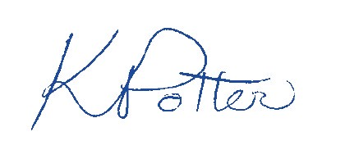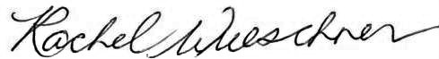

Kate Potter, Mayor Rachel Wueschner, Town Administrator

